Special Instructions
- javac *.java
- java Main

*Note, this project was compiled with Java 23. To run the program successfully, ensure your system uses the same or a newer version of Java.

* Note on runtime: Part 3.2 and Part 3.3 take about 1 minute and 30 seconds to run completely. This is because the brute-force approach we took tests all the possible key combinations and writes two output files per question that show the key used and the decrypted message.

To save time, we included the final answers in the terminal so you do not need to wait for the program to finish.
Answers
Part 1. - SDES
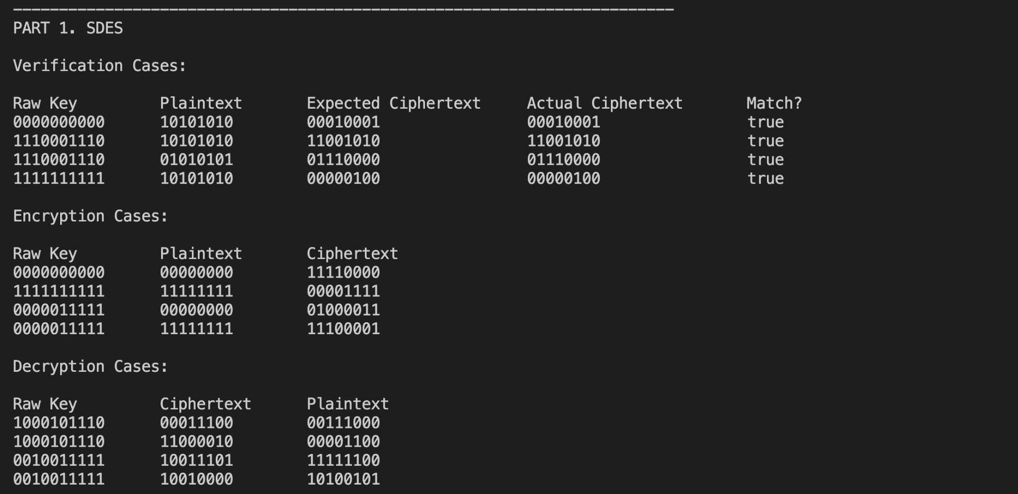

Our group divided the Part 1 answers into three cases. The first case was to ensure that our answers align with the ones provided. The encryption case is to the first four missing values meanwhile the decryption cases answer the remaining 4 missing values. They are as follows
- 11110000
- 00001111
- 01000011
- 11100001
- 00111000
- 00001100
- 11111100
- 10100101
Part 2. - Triple SDES
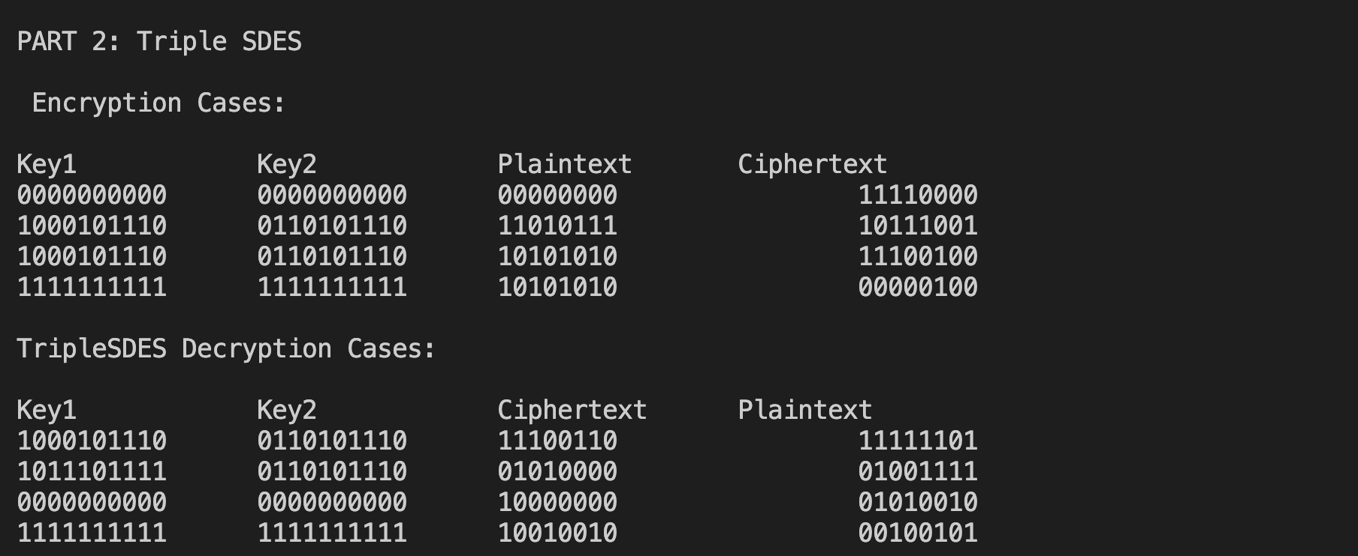

Similar to Part 1, we divided the answers into the two cases. The values we got are as follows:
- 11110000
- 10111001
- 11100100
- 00000100
- 11111101
- 01001111
- 01010010
- 00100101

Part 3. - Cracking SDES and TripleSDES

3.1) 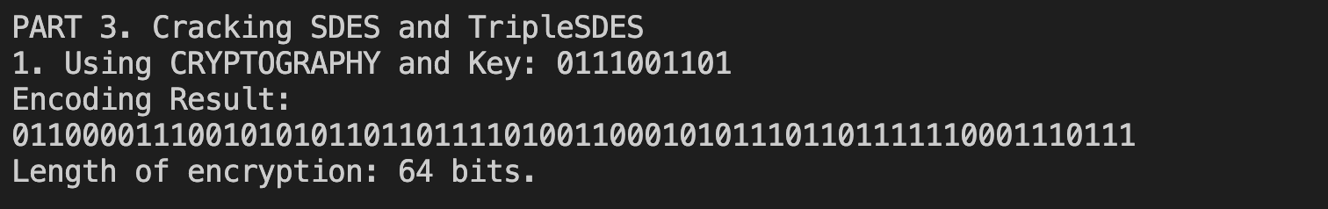

Answer
Encoding Result:
0110000111001010101101101111010011000101011101101111110001110111
Length of encryption: 64 bits.

3.2) Approach: To find the decrypted message, we used a HashSet that stored common English Words like “the”, “and”, “or”, etc. For each key we attempted, the program used the decrypted message and checked if it included any words from our set. If it did, then that attempt is written into our “special”.txt file. After running all the possible combinations, we manually search the special.txt file using (Control F) with the word “the”. From those, we were able to identify the correct key and plaintext.

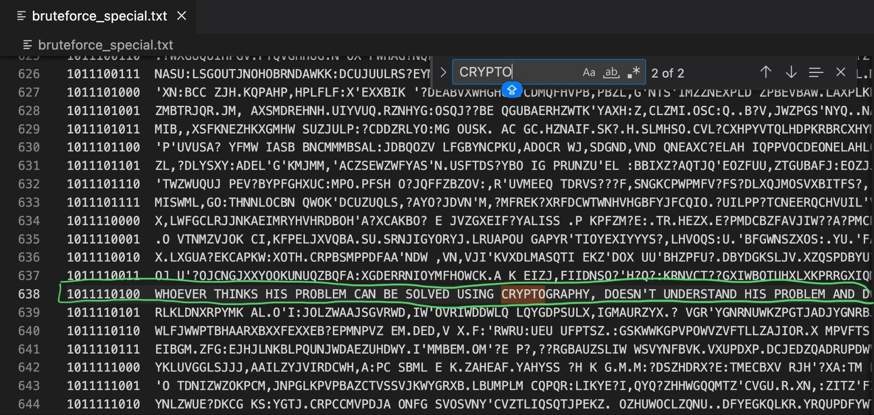

Answer
Key: 1011110100
Message: WHOEVER THINKS HIS PROBLEM CAN BE SOLVED USING CRYPTOGRAPHY, DOESN'T UNDERSTAND HIS PROBLEM AND DOESN'T UNDERSTAND CRYPTOGRAPHY. ATTRIBUTED BY ROGER NEEDHAM AND BUTLER LAMPSON TO EACH OTHER

3.3) Approach: We followed a similar approach to 3.2, but this time it was trying all the possible combinations of 2 keys. (Answer and screenshot on the next page)

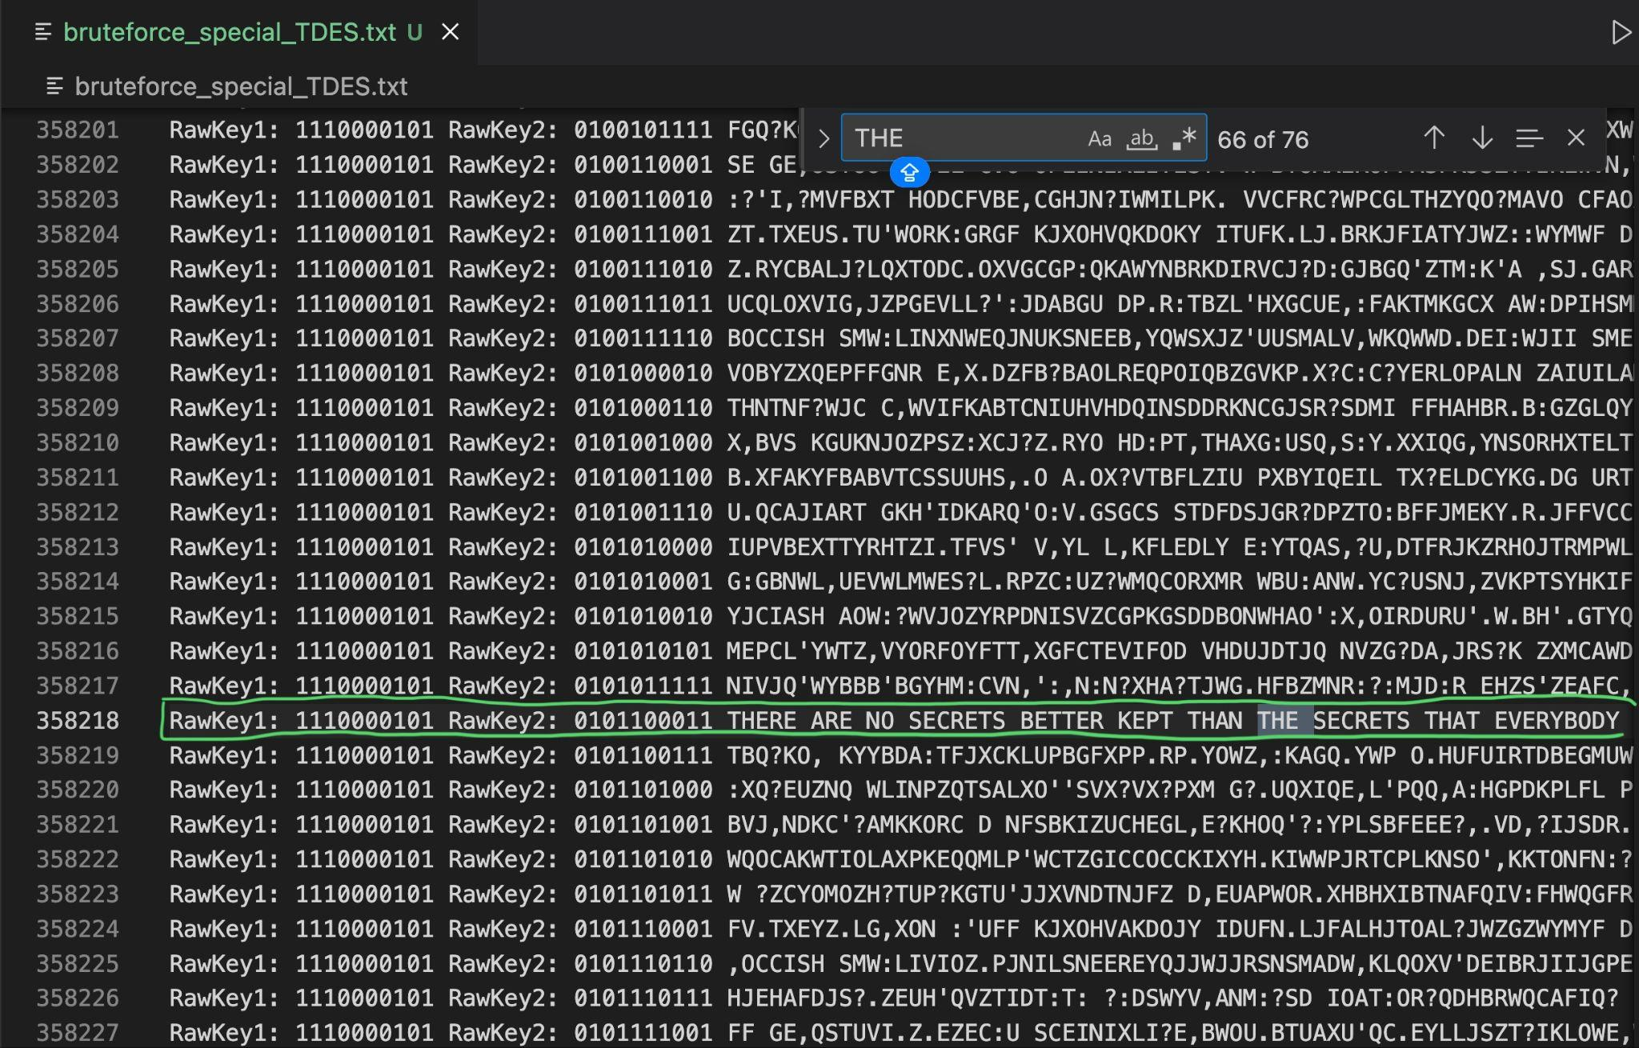
Answer
Key1: 1110000101 and Key2: 0101100011
Message: THERE ARE NO SECRETS BETTER KEPT THAN THE SECRETS THAT EVERYBODY GUESSES.

